Commercial Automated Pet Feeder

A PROJECT REPORT

Submitted by

NAME OF THE CANDIDATES

Divya Khedkar (20213220181137210152)
Shashwati Salunke (20213220181124610024)
Akanksha Deshpande (20213220181150710002)

in partial fulfillment for the award of the degree

of

Bachelor of Technology

IN

COMPUTER SCIENCE & ENGINEERING

Guided by
Prof. Jayshri Pagare

Computer Science & Engineering

MGM’s Jawaharlal Nehru Engineering College, Aurangabad

YEAR 2021- 2022

COMMERCIAL AUTOMATED PET FEEDER

A PROJECT REPORT

Submitted by

Divya Khedkar
Shashwati Salunke
Akanksha Deshpande

in partial fulfillment for the award of the degree

of

BACHELOR OF ENGINEERING

in

COMPUTER SCIENCE & ENGINEERING

Guided By

Prof. Jayshri Pagare

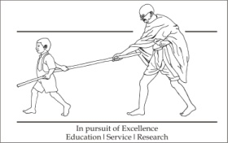

Department of Computer Science & Engineering

MGM’s Jawaharlal Nehru Engineering College, Aurangabad

YEAR 2021-22

CERTIFICATE

This is to certify that the project report
“Commercial automatic pet feeder”
Submitted by

Divya Khedkar 20213220181137210152
Shashwati Salunke 2021322181124610024
Akanksha Deshpande 20213220181150710002
is a bonafide work carried out by them under the supervision of Prof. Jayshree Pagare, it is approved for the partial fulfillment for award of Bachelor of Technology (Computer Science & Engineering ), degree of Dr. Babasaheb Ambedkar Technological University, Lonere.

Date:

Prof. Jayshri Pagare Dr. Vijay Musande
Guide Head of Department
Dept. of Computer Sci. & Engineering Dept. of Computer Sci. & Engineering

CONTENTS

List of Figures 17
Abstract

1. INTRODUCTION 6

1.1 Introduction
1.2 Necessity

2. LITERATURE SURVEY 8
3. PROBLEM DEFINITION and SRS 10
  - Problem Definition
Problem Statement
Objectives
Major Inputs
Major Outputs
Major Constraints
Hardware Resources Required
Software Resources Required
Area of Project
  - Software Requirements Specification
    - Introduction
Purpose
Scope of the Project
Intended Audience & Reading Suggestions
    - Data Model and Description
  - Data Objects described in detail

    - Functional Model and Description

4. SYSTEM DESIGN and IMPLEMENTATION 25
4.1 Proposed System Architecture
4.2 Design ER, DFD or suitable diagrams
4.3 Implementation Details (Specific to project)
4.4 Timeline Chart
4.5 Cost Estimation
5 PERFORMANCE ANALYSIS 29
5.1 Different Modules and their working, Output Screens
5.2 Analysis
5.3 Testing
6 CONCLUSIONS 31
6.1 Conclusions
6.2 Future Scope
References 33
Acknowledgement 34

*******

1. INTRODUCTION

1.1 Introduction

An automatic pet feeder is provided for feeding pets predetermined quantity of food or medication at predetermined times while the owner is absent or otherwise engaged. The pet feeder comprises a base, a feeding bowl with pie shaped divisions, a timer module, a bowl cover, handle to bowl cover and locking mechanism to hold the entire unit in place. A timer is provided with voice recording facility and also initiates programmed feeding schedules. The programming of the timer determines when the feeder cover is indexed so that the pet may have access to the food provided in it. This programming can be done through the timer interface RF or IR remotes and or through an USB port interface to a computer.

The Commercial Automated Pet Feeder is an IOT based project which does the basic functioning of any pet feeder in the market, i.e. dispensing at timely intervals and additionally uses sensor technology to collect relevant data and in turn generate appropriate insights about the animal’s eating habits. Also, the project will be pre-programmed with inbuilt instructional codes which will include the food type of animal breed associated with the gender intake. Hence, considering all the aspects and then associating the program that will be responsible for each cell in the pound or shop, the user will just have to update the project with the cell numbers and the type of animal kept in the respective cell. This way, the functioning will begin accordingly and automatic dispensing at defined time intervals will occur.

1.2 Necessity

The hectic lifestyles often prevent us from spending enough time with our beloved pet babies. Busy schedules, work trips, late-night meetings…the list is endless. When it comes to us, our pets are just one portion of our lives. On the flip side, for our pets, we are their whole lives.
Having a smart automatic pet feeder is an excellent way of making sure your pet’s nutritional needs are taken care of while you are away from home.

As creatures of habits, dogs and cats like having the same schedules every day. Therefore, using a smart automatic pet feeder has both emotional and physical benefits for the pet. The emotional wellbeing is ensured by maintaining the consistent feeding schedule. Following the same pattern every day makes your pet feel secure.

As for the physical benefits, using an automatic feeder is an excellent way of preventing obesity. Having a strict and consistent schedule will allow you to monitor your pet’s nutritional intake every day. Plus, it is a good way of knowing how much your pet eats. For example, if your pet’s appetite is decreased and you are free-feeding it chances are you will not be able to notice the decrease unless it is significant. With the automatic pet feeder, even the slightest changes will be noticed.

LITERATURE SURVEY

Vania, K. Karyono and I. H. T. Nugroho, "Smart dog feeder design using wireless communication, MQTT and Android client," IOT pet feeder hacker. Tv.io this design uses a Pringles can to store the food, and a shorter soup-style can to act as the bottom of the dispenser, and to hold a hobby servo.
IOT based PET Feeder (researchgate.net) This paper is written by Abdulla. The proposed system is divided into two main sectors including measurements and control units. System performs periodic measurements of the pet’s weight and food level inside the tank. On the control unit, the system can operate under smart mode where the user can define the energy fact of the food inside the tank and type of the cat. The cats weight will be, further, measured and the system can compute the right amount of the food to be dispensed to the cat.
J. Jung, C. Ji, J. Sohn, H. Meng and B. Hwang, "NuriPet: A smart pet feeding machine for SNS," 2016 IEEE International Conference on Consumer Electronics (ICCE), Las Vegas, NV, 2016,machine learning technique in eating behaviour e-coaching. In this paper we will present an algorithmic process that utilises EMA methods for developing a machine learning based approach in order to provide adaptive semi-individualized feedback to users regarding their eating behaviour. Our machine learning pipeline (based on decision trees and clustering algorithms) takes as input the user collected data (through the EMA) and provides information regarding possible unhealthy eating events
Robert Fleming Vishak Ganesh Vu Tang Viet Nguyen Kevin Clark . Modified automatic pet feeder slideshow on benefits of using automated pet feeders. Automatic pet food dispensers can be easy and convenient for feeding your pets, but they're not right for every pet's dietary needs. Understanding the pros and cons of these devices can help you decide if one can be suitable to feed your pet.
Shiham K 2017 Pet obesity survey result, towards Automatic & Personalised Mobile Health Interventions: An Interactive Machine Learning Perspective Machine learning (ML) is the fastest growing field in computer science and healthcare, providing future benefits in improved medical diagnoses, disease analyses and prevention. In this paper, we introduce an application of interactive machine learning (IML) in a telemedicine system, to enable automatic and personalised interventions for lifestyle promotion.

S. Hassan HosseinNia, Inés Tejado, Blas M. Vinagre, Automated pet feeder using internet of things. Over half of the people in the world intentionally have pets as their companions, but these pets are becoming a burden to the pet owners. There is a lot of stress for the owner while feeding their pets. Over the years different automatic pet feeders are available in the market, but none of them are still not able to solve a lot of problems like overeating, obesity. This project aims in rectifying the problems caused by existing feeders and designing efficient automatic pet feeders using the internet of things. This Automatic pet feeder uses a NODEMCU Micro Controller and consists of an interface with DC servo motor, relays, water pump and other hardware equipment. A software code is dumped into the microcontroller to perform operations like rotating motors and switching relays on and off.

C. Sammarco and A. Lera, “Improving Service Manage-ment in the Internet of Things,”Simple Effective and Robust Weight Sensor for Measuring Moisture Content in Food Drying Process. Measurement values using weight sensors are inherently contaminated by noise generated from electrical sources, thermal dynamics, mechanical vibration, and environmental conditions. In this paper, we present a method of correcting the accuracy of the sensors by using filtering algorithms. Two well-known methods in electrical engineering, namely, low-pass filtering and the algorithm, are applied to correct the real-time measured weight under various temperatures to determine moisture content during the food drying process. From an experiment using pineapples as the food material, the results showed the effectiveness of the application even if it has a simple design and is easy to implement.

Tessema Gelila Berhan, Worku Toyiba Ahemed, Tessema Zelalem Birhan, “Programmable Pet Feeder”, values using weight sensors are inherently contaminated by noise generated from electrical sources, thermal dynamics, mechanical vibration, and environmental conditions. In this paper, we present a method of correcting the accuracy of the sensors by using filtering algorithms. Two well-known methods in electrical engineering, namely, low-pass filtering and the algorithm, are applied to correct the real-time measured weight under various temperatures to determine moisture content during the food drying process. From an experiment using pineapples as the food material, the results showed the effectiveness of the application even if it has a simple design and is easy to implement
Seungcheon Kim, Automatic Pet Food Dispenser by using Internet of Things (IOT)The objective of this project is to develop an automatic pet feeding with Internet of Things (IOT). We developed a feeder to help allocate dry food diets to small pets such as dogs and cats. It will be very useful whenever a pet owner is outside the residence and/or unable to feed his/her pets normally. When free feeding happens, it will cause the obesity of pets. This machine will be also used for monitor pet's eating habits to train the pets for scheduled

3. PROBLEM DEFINITION and SRS

  - Problem Definition

Problem statement
Automated commercial pet feeder can be one of the new technologies for feeding pets on a large number. It will help shop owner to take care of the pets from anywhere and anytime can still can feed them.

Objectives
Our project is designed to help all the pet owners to feed their pets remotely and smartly.
Benefits to customer:
Owners will be able to feed the correct amount of food to their pets by setting it on the website. The information will be transferred to the PCB via Wi-Fi, which will send signals to food dispensing gates.
Owners will be able to monitor their pet’s health condition via their daily consumption of food recorded by the website. Sensors will be embedded on the food plate, which measures the difference of weights by the end of each day. Information will be processed by PCB and sent to the phone app.
Owners with two different types of pets will be able to feed them separately with corresponding food. In particular, a household can have dogs of different ages that need different food or if the owner owns both a dog and cat and does not want them to eat the wrong food by accident. Each pet will have a RFID tag. When the RFID receiver identifies the type of animal, the correct angle of the food plate will be spun so that the corresponding food will be exposed.

Product features:
The project could set the correct amount of food to drop at the correct time.
The website could save a pet profile (name, age, weights) for owners to keep track.
The website could keep track of how much food the pets have consumed in a long run graphically.
The user will have to simply fill details once so that the project will differentiate types of pets for different food needs.
In future, the user can also update just on the cells when any of the house pet is changed i.e. sold or anything else.

Major input
Input consists of a storage material which consists of the food granules. The food is dispensed from the storage through the pipe in bowl. Between the pipe consists of node mcu which senses the food

Major output
The output consists of the bowl which has food

Major constraints
1. Machine dependency-Automated work leads to machine dependency.
2. Unemployment-Machine dependency will increase unemployment.
3. Less human interaction-As real time monitoring will provide all the data hence there’s no such need of human interaction.

Hardware required

1] NODEMCU
The Node MCU (Node Micro Controller Unit) is an open source software and hardware development environment that is built around a very inexpensive System-on-a-Chip (SOC) called the ESP8266. The ESP8266, designed and manufactured by Systems, contains all crucial elements of the modern computer: CPU, RAM, networking (WIFI), modern operating system and SDK. When purchased at bulk, the ESP8266 chip costs only 400Rs a piece. That makes it an excellent choice for IOT projects of all kinds .It has also Wi-Fi capabilities, so we can control it wirelessly and make it work on a remote installation easily! We can tell our board what to do by sending a set of instructions to the microcontroller on the board. To do so we can use the Arduino UNO Software (IDE).
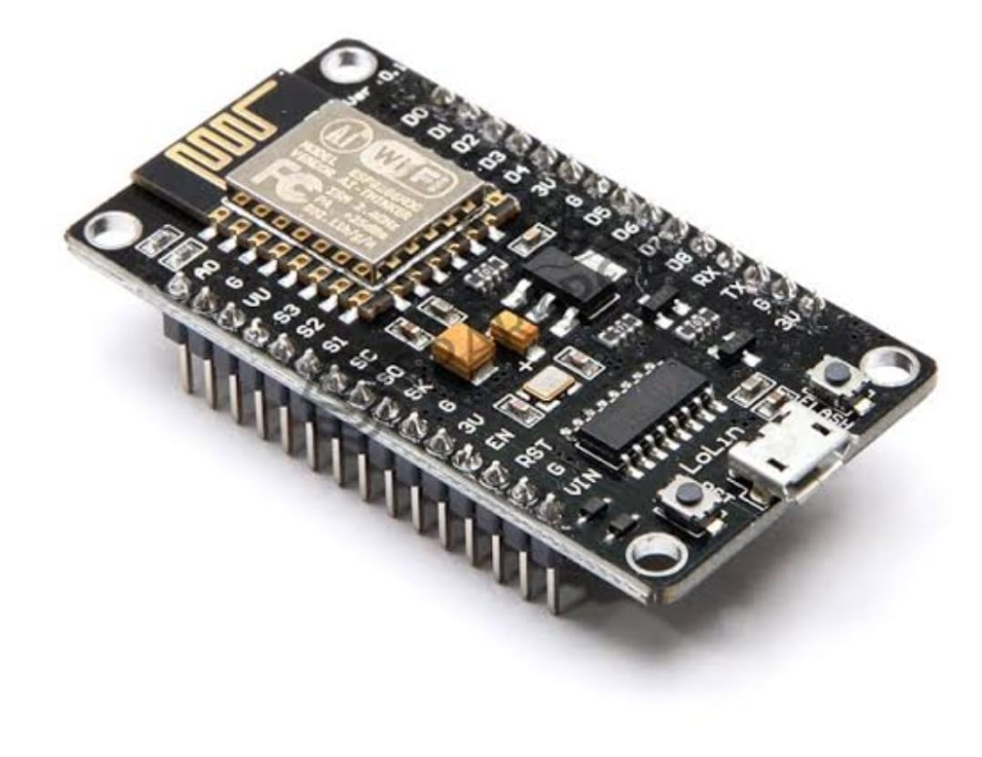
(1)

2] Load cell
A load cell is a force transducer. It converts a force such as tension, compression, pressure, or torque into an electrical signal that can be measured and standardized. As the force applied to the load cell increases, the electrical signal changes proportionally. The most common types of load cell used are strain gauges, pneumatic, and hydraulic.
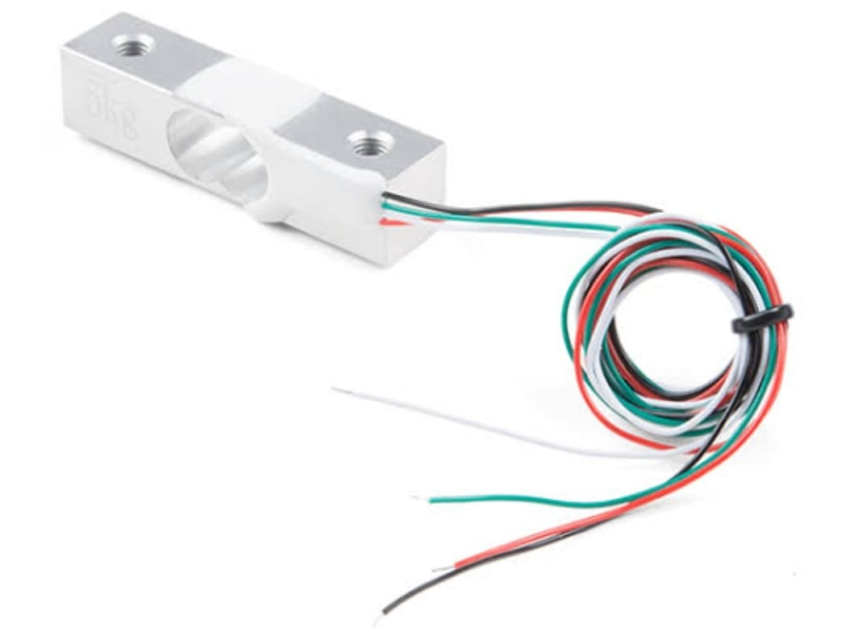
(2)
3]HX711
Based on Avian Semiconductor's patented technology, HX711 is a precision 24-bit analog- to-digital converter (ADC) designed for weight scales and industrial control applications to interface directly with a bridge sensor. The HX711 is a precision 24-bit analog-to-digital converter (ADC) that is designed for weighing scales and industrial control applications to interface directly with a bridge sensor.
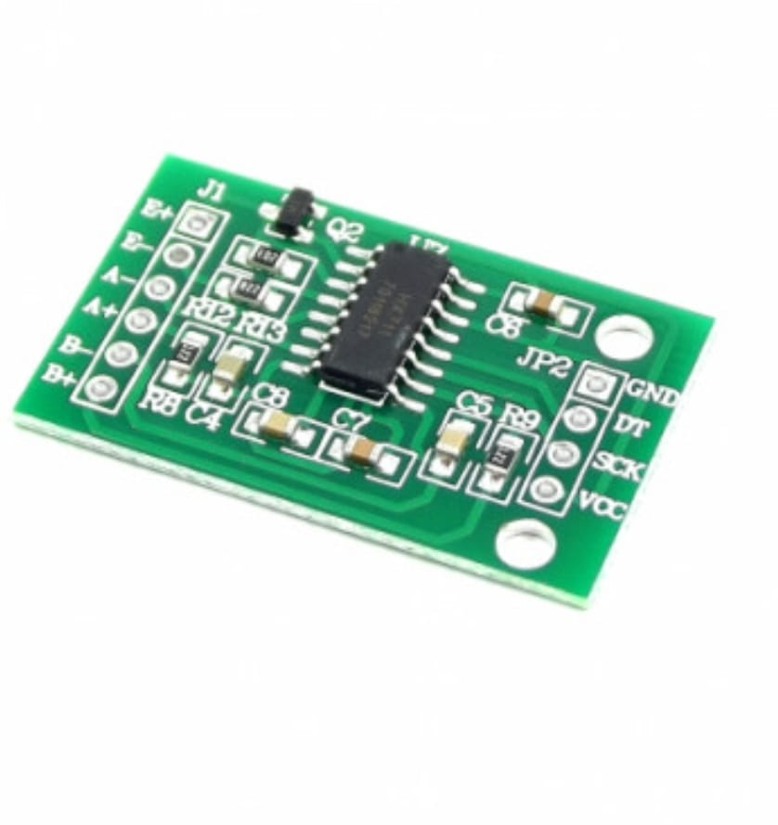
(3)

4] Motor driver
Motor drive means a system that includes a motor. An adjustable speed motor drive means a system that includes a motor that has multiple operating speeds. A variable speed motor drive is a system that includes a motor and is continuously variable in speed. If the motor is generating electrical energy rather than using it – this could be called a generator drive but is often still referred to as a motor drive

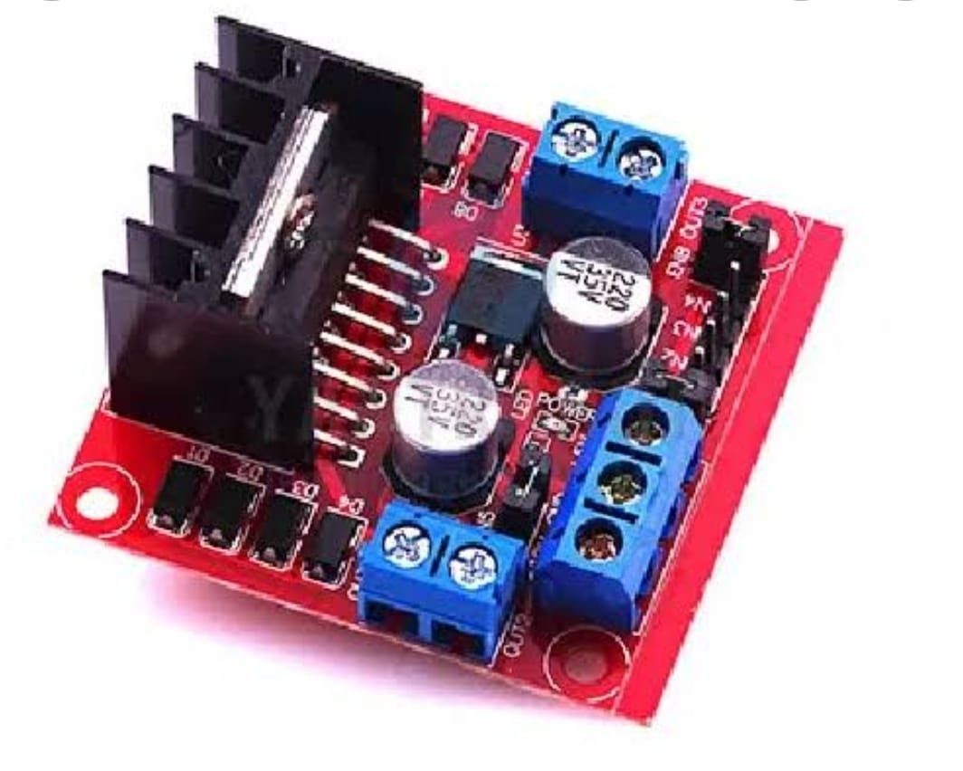
(4)
5] DC motor
An electric motor is an electrical machine that converts electrical energy into mechanical energy. Most electric motors operate through the interaction between the motor's magnetic field and electric current in a wire winding to generate force in the form of torque applied on the motor's shaft. Electric motors can be powered by direct current (DC) sources, such as from batteries, or rectifiers, or by alternating current (AC) sources, such as a power grid, inverters or electrical generators. An electric generator is mechanically identical to an electric motor, but operates with a reversed flow of power, converting mechanical energy into electrical energy
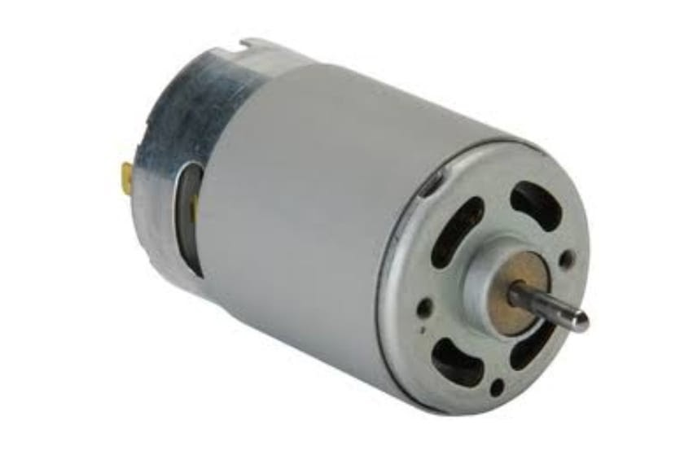
(5)

Software Requirement

Machine Learning
Machine learning is the science of computer algorithms that can learn and develop on their own with experience and data. It is regarded as a type of AI technology. Machine learning algorithms make a framework based on training data to make predictions or judgments without having to be explicitly programmed to do so. Machine learning algorithms are applied in a wide range of areas, including medicine, spam filtering, speech recognition, and computer vision, where developing traditional algorithms to do the required tasks is difficult or impossible.

However, not all machine learning is statistical learning. A subset of machine learning is strongly related to computational statistics, which focuses on making predictions using computers. The discipline of machine learning benefits from the study of mathematical optimization since it provides tools, theory, and applicastion domains. Data analysis is a similar branch of research that focuses on unsupervised exploratory data analysis. Data and neural networks are used in some machine learning implementations to replicate the functioning of neural impulses. Machine learning is also known as predictive modelling when it is used to solve business challenges.

In general, there are two types of approaches based on the concept of machine learning which are supervised and unsupervised learning, the former of which we used.
In general, there are two types of approaches based on the concept of machine learning which are supervised and unsupervised learning, the former of which we used.

Supervised Learning: The most common type of training data used in deep classification is labelled data. In training data, there are numerous inputs and a "labelled" output. These labelled outcomes are used by models to assess themselves during training in order to enhance their capacity to predict new data. Typically, supervised learning models focus on regression and classification methods. Categorization problems are fairly common in medicine. A doctor diagnoses a patient in most clinical settings by identifying the condition based on the symptoms. The purpose of regression problems is to predict quantitative outcomes, such as the length of a patient's stay in a clinic, using a set of factors including vital signs, clinical records, and weight. Some of the most common algorithms under the supervised learning are Linear Regression, Logistic Regression, Decision Tree, Random forest, Support Vector Machine. Even Neural Networks can be trained via supervised learning.

Unsupervised Learning: Here, the data has no labels and it self organizes the model to find patterns in the dataset. Unsupervised learning looks for patterns in data that hasn't been tagged. Such algorithms are usually good at grouping data into useful groups, enabling for the identification of latent traits that aren't readily evident. These are, generally, more technically expensive and take a greater quantity of data to complete.

Dataset

The data comes from Austin Animal Center from October 1st, 2013 to March, 2016. Outcomes represent the status of animals as they leave the Animal Center. All animals receive a unique Animal ID during intake.
Dataset has the following features:-
- Name: Name of the animal, if it had one.
- Date Time : Timestamp at which it was brought in the shelter home
- Outcome Type: Outcome of the animal, 5 classes to predict.
- Outcome Subtype: Much granular detail of the type of the outcome for that specific animal.
- Animal Type: Type of Animal, Dog or Cat.

- Sex-upon-Out-come: Sex of the animal, when they leave the shelter home. (Don’t know why its mentioned ‘Sex-upon-Outcome’ and not just 'Gender'? It kind implies there might be a difference between 'Sex-upon-Outcome' and 'Sex-upon- Intake' that they troubled themselves to name it this way.)
- Age upon Outcome: Age of the animal when they came out of the shelter home.
- Breed: Breed of the animal.
- Color: Color of the animal.

Experimental setup

We've detailed all of the parameters used to train our models in this section. For Random Forest, we took the number of estimators as 400 and the criteria as ‘entropy’, the default value of which is ‘gini’. For Logistic Regression, we took the value of maximum iterations as 200, keeping the solver as ‘lbfgs’ and considered the value of the inverse of regularization strength as 0.1. For Decision Tree, we took the criteria as ‘entropy’, the same which we took for random forest. All the experiments were conducted in Python 3.8. The simulation was run on Google Colaboratory, which has an Intel(R) Xeon(R) processor running at 2.30GHz, 13GB of RAM, and an NVIDIA Tesla K80 GPU.

Results and discussions

The figures below shows a graphical representation of the entire dataset, providing intuitive details regarding the dataset such as Gender distribution, Top 10 Breeds in the past decade, breeds preferred the least, a heat-map showing the correlation between the columns and so on and so forth. Various models were implemented such as Logistic Regression, Decision Tree and Random Forest, of which Logistic Regression outperformed all the other models with an overall accuracy of 78.3%. We made new predictions using the Test set.

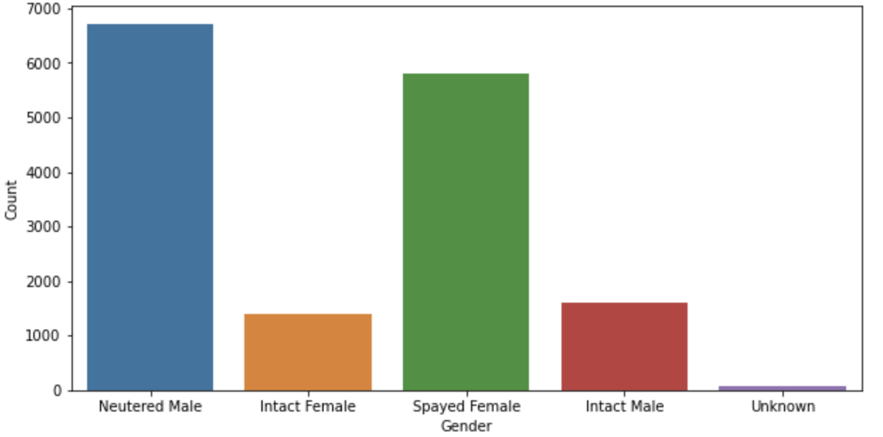
(6)

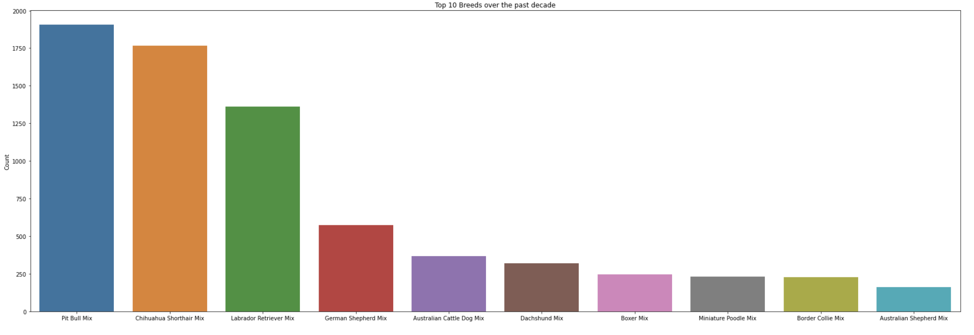
(7)

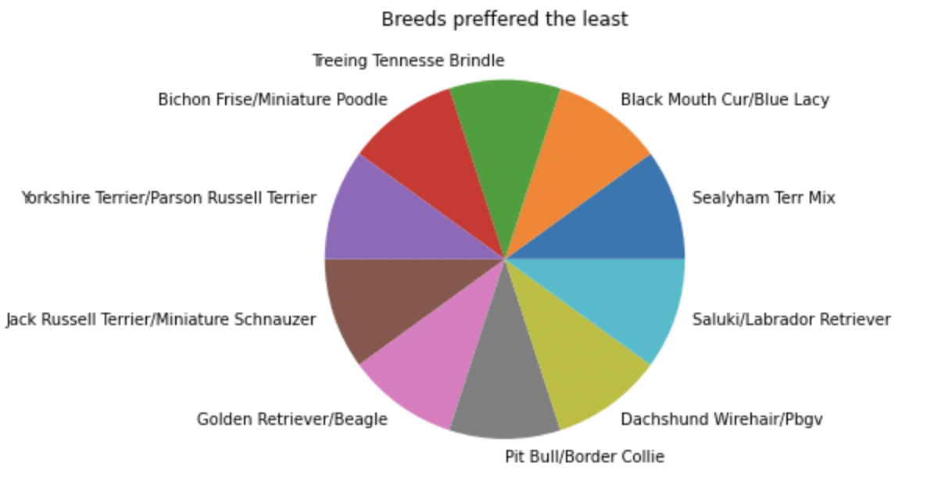
(8)
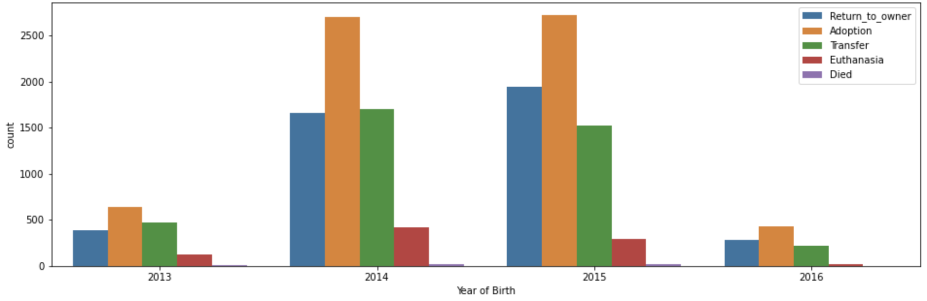
(9)

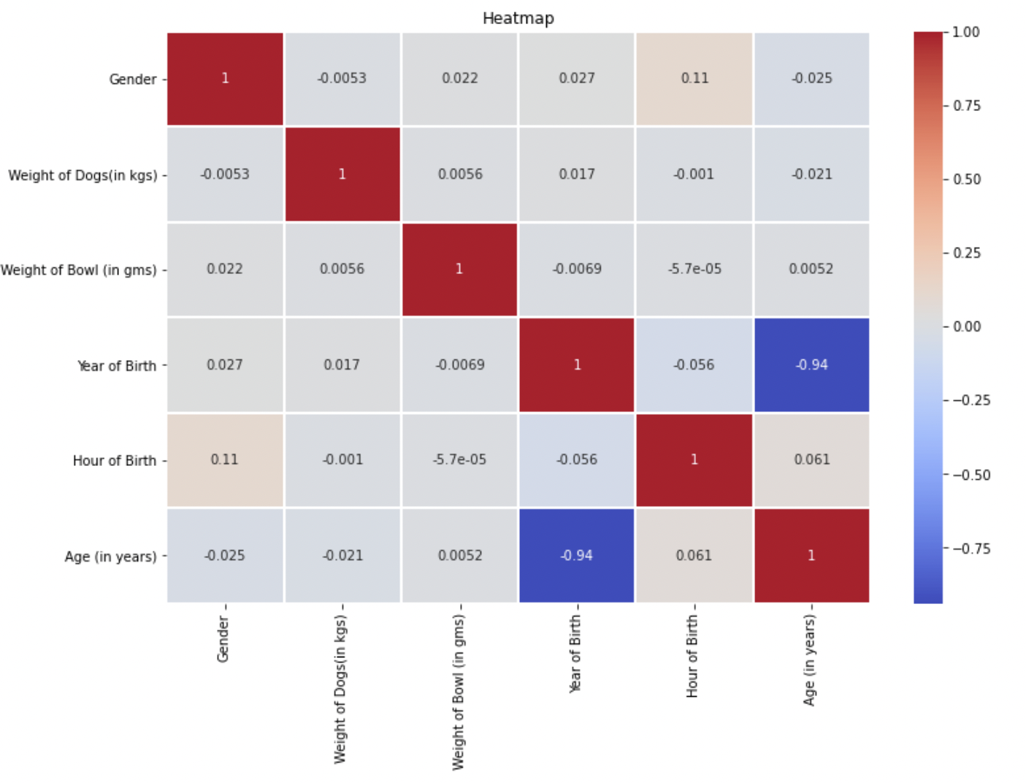

(10)

Web page
We are using html, CSS, JS for making front-end. The records of the system are fetched in the front-end and stored there. We can update, delete the data of the system from here. The data manipulated from machine learning algorithms are reflected here.
Web page is attached to a machine algorithm which collects the data from the sensor. The web site contains the contents of the project. It is responsive website .It is a web page which give idea about the complete project
Blynk
With blynk, you can create smartphone applications that allow you to easily interact with microcontrollers or even full computers such as the Raspberry Pi. The main focus of the Blynk platform is to make it super-easy to develop the mobile phone application. As you will see in this course, developing a mobile app that can talk to your Arduino is as easy as dragging a widget and configuring a pin.
With Blynk, you can control an LED or a motor from your mobile phone with literally zero programming. This is actually the first experiment that I will demonstrate in this course.
But don’t let this simplicity make you think that Blynk is only useful for trivial applications. Blynk is a robust and scalable tool that is used by hobbyists and the industry alike. You can use it to monitor the soil humidity of your vegetable garden and turn on the water, or open up your garage door, with your phone.
You can also use it to control smart furniture that can learn from your routines, or embed IoT and AI to traditional industrial products such as a boiler, or for improving the integrity and safety of oilfields.
Blynk is free to use for personal use and prototyping. Their business model generates profits by selling subscriptions to businesses that want to publish Blynk-powered apps for their hardware products or services.

3.2 Software Requirements Specification

3.2.1 Introduction

Purpose
Automatic pet feeders are meant to dispense a specified amount of food at a designated time so you don't have to. Although they sound like a great solution to caring for your pet while you're away, they're not always reliable, nor are they built with most pets in mind.

Scope of the Project
he pet feeder will be customizable in the way that the quantity and time of food released will be controlled, the system will be able to hold any type of pet food and which type will be dispensed. The system will have a time and will be automatic. The inputs include clock times, set time from the user, customized food amount and an on/off for the system. The results of the system will display the time and at the set time, a motorized latch will open and close and ring an alarm. The food will be controlled by a latch and the liquids will be controlled by a valve. This will be both a sequential and combinational logic design. The inputs will be a timed clock circuit and counters which will cause the motors to run.

Intended Audience & Reading Suggestions
Automatic and smart pet feeders aid in the timely feeding of pets.
Automatic and smart pet feeders specifically suit traveling professionals and pet owners who are on business trip.

Data Model and Description
Data Objects described in detail. Data set is real-time, which consists of the age, gender, breed of pet. Data set also consists of the amount food in the bowl, with the help of ML algorithms we can get the required information of food habits of pet.
Functional model
1 .home: the page consists of different login product, contact and about
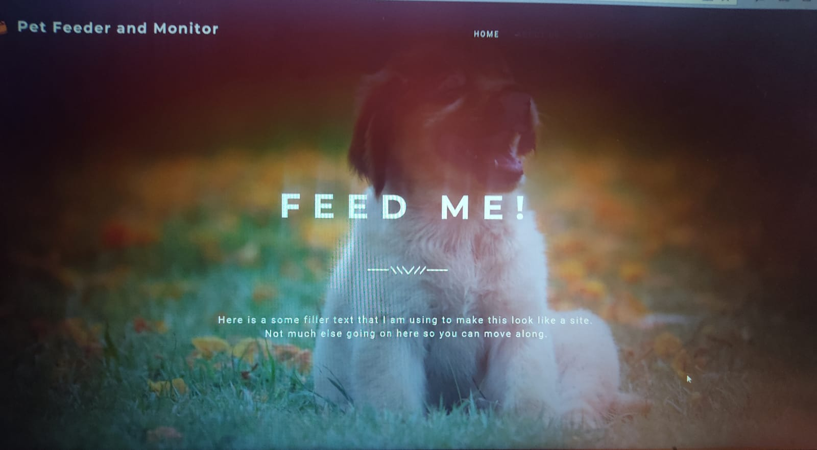
(11)
2.login: login page for user
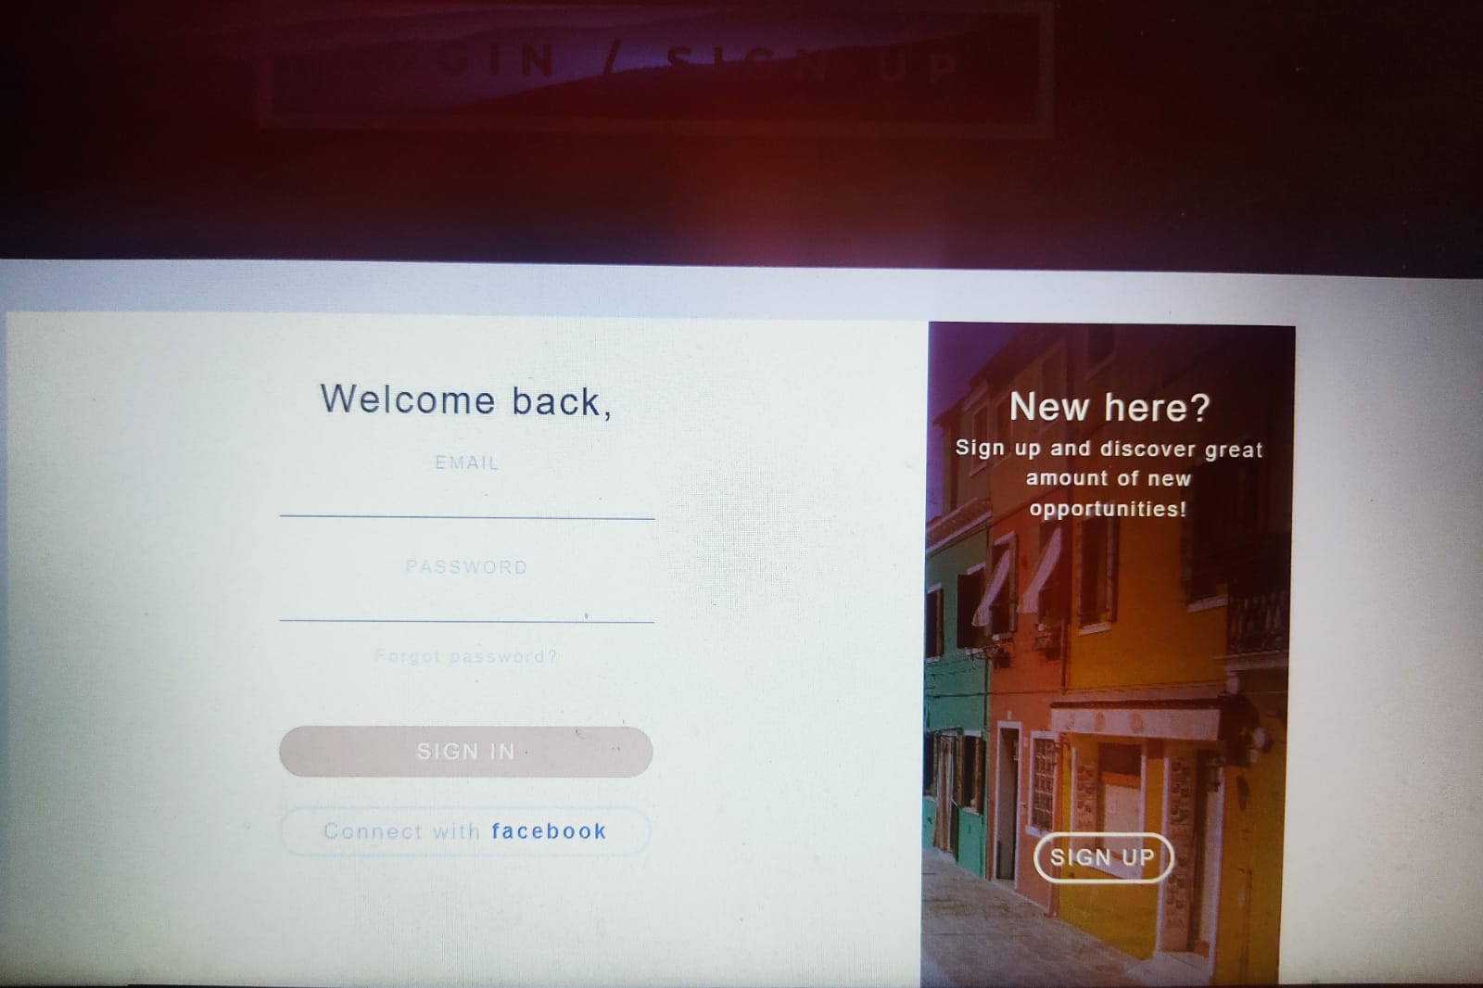

(12)

- about : this page consists of information of product
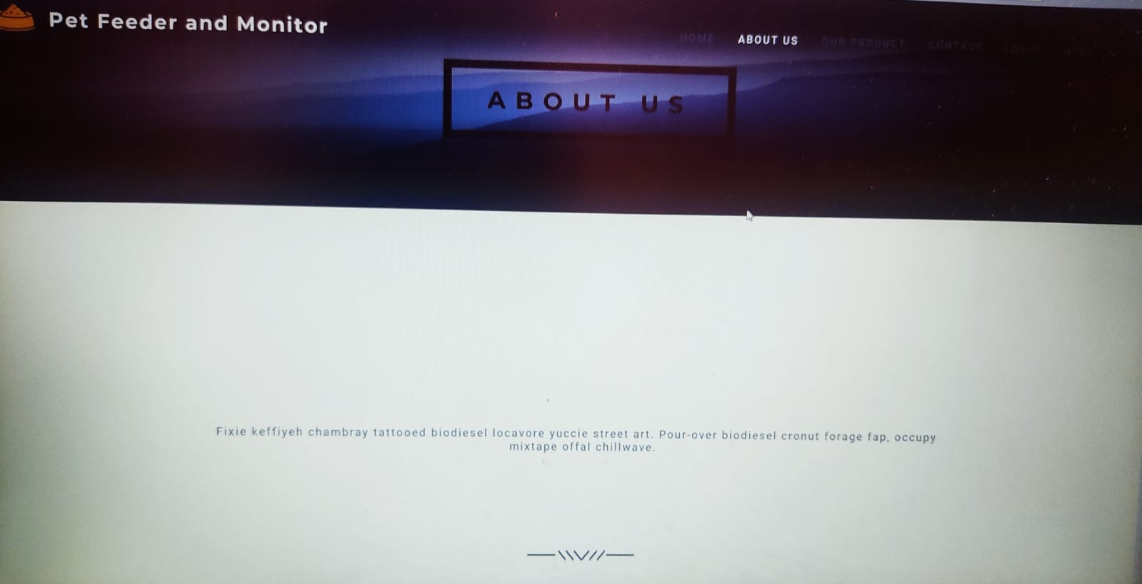
(12)
4.contact: the contact page can used to contact which consists of Name, email, phone-number

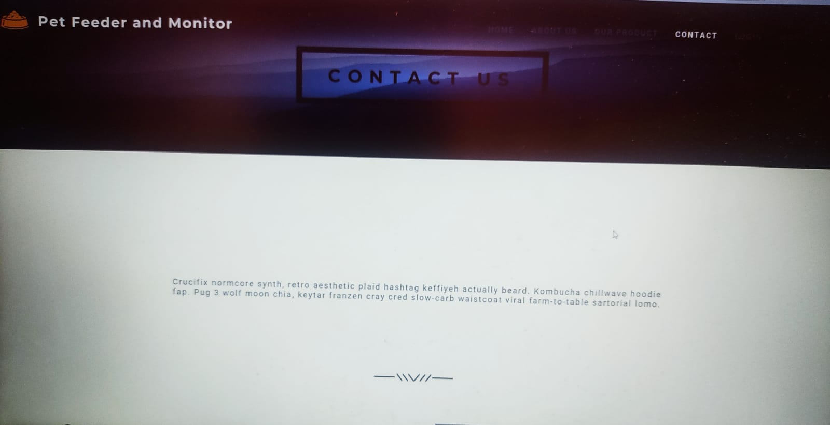

Functionality diagram of automatic pet feeder
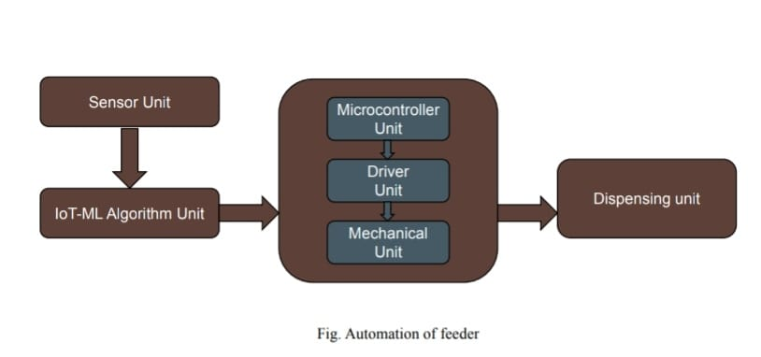
(14)

- SYSTEM DESIGN and IMPLEMENTATION

4.1 Proposed System Architecture

Sensors Measuring Food Containers
Two identical cylindrical containers will be assembled at the top of the machine, with a weight sensor attached to the bottom of each container. The sensors will be taking measurements constantly and sending their data to the microcontroller, while the microcontroller stores data only when an action of food dispense has occurred.

Sensors Measuring Food Plates
There will be two separate food plates in the shape of half circles. Two weight sensors, one for each half of the food plate, will be attached to the bottom of the plates. The sensors will keep track of the amount of food the pets have consumed. The sensors will be taking measurements constantly and sending their data to the microcontroller, while the microcontroller stores data on specified time of the day.

Website for project monitoring
We are using html, CSS, JS for making front-end. The records of the system are fetched in the front-end and stored there. We can update, delete the data of the system from here. The data manipulated from machine learning algorithms are reflected here. Web page is attached to a machine algorithm which collects the data from the sensor. The web site contains the contents of the project. It is responsive website which can be used both on mobile and computer. It is a web page which give idea about the complete project

4.2 Design ER, DFD or suitable diagrams

Data flow diagram
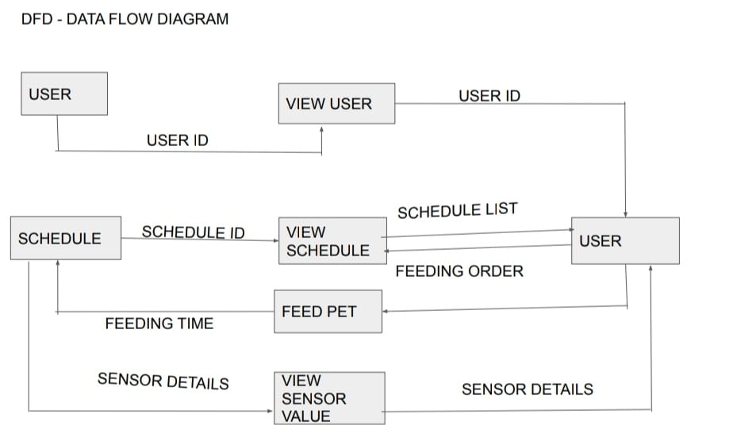
(15)

(16)

ER-diagram

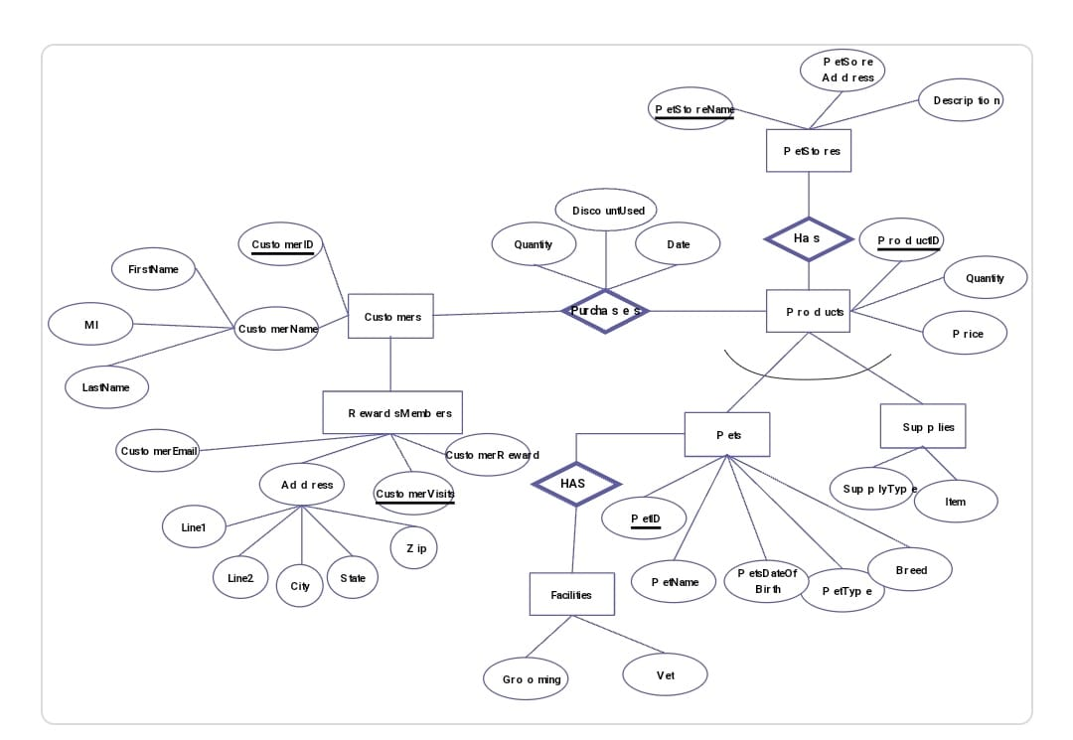

4.3 Timeline Chart
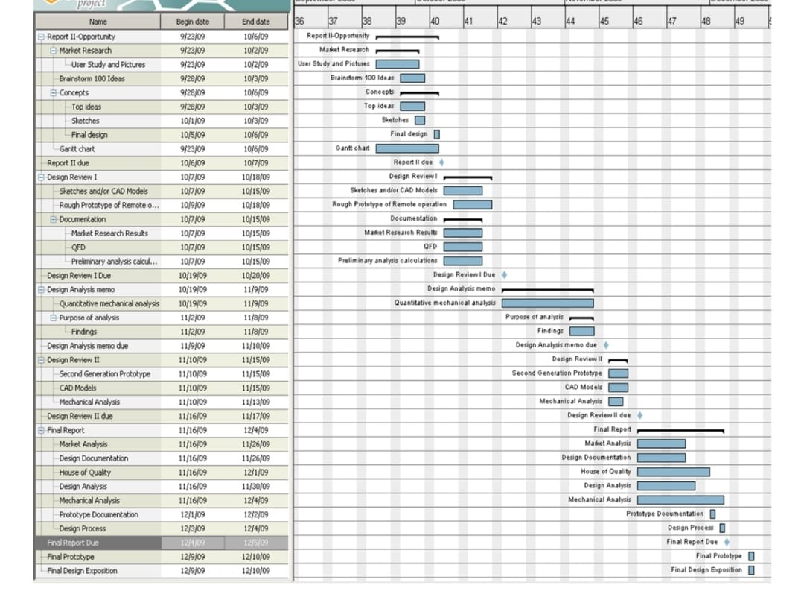
(17)

4.5 Cost Estimation
The total cost of project is nearly 2000.It includes cost of mostly all the hardware parts used in the project.

- ANALYSIS

5.1 Different Modules and their working, Output Screens

SENSING - The sensors will work in order to sense the amount of food present in the vessel.
PRE DEFINED INSTRUCTIONS - The system will consist of pre- defined instructions based on the type of breed, age of the pet and accordingly the quantity of food will be stored to be followed. Hence, the empty space recognized by the system will be filled.
ONE TIME CONFIGURATION- INPUT FROM USER (CELL NO., AGE, BREED).- The user will have to enter some specifications into the system about the number of cells, pets, their breeds and their age. Accordingly the project will automatically allocate the task to each specific cell.

5.2 Analysis

Pets have become an integral part of families across the world and their well-being is a rising concern among owners owing to their busy lifestyle. The growing concern for the health of pets has resulted in a surge in pet service products, as a result the demand for pet feeders has increased.

Conventional pet feeders were used to serve food to pets in the past. Of late there are automatic and smart pet feeders available in the market, which enables pet owners to feed their pet with different type of food at specific time of the day without being present physically.

Pet owners are unable to spend quality time with their pets due to lack of time caused by hectic lifestyle. This leads to increase in demand for pet feeders and mainly smart and automatic pet feeders.

Customers living in digitized homes are increasingly demanding the up-gradation of
automatic and smart pet feeder. These feeders are gaining popularity as they are equipped
with technology to connect end users with their pets using mobile devices or with built in
cameras.

5.3 Testing
Testing includes the functioning of website, the ML algorithm, and hardware
Processing

- CONCLUSIONS

6.1 Conclusions

The Automatic Pet Feeding System was planned to ensure the weight in the bowl. It gives the readings and keeps the records of the reading .The machine learning algorithms gives the graphs on the web page. The web page is the main frontend which gives the records of the eating habits of the pet

6.2 Future Scope

Scope of project the Future Implications are very vast of this type of technology. This technology can also be used with the Home Automation technologies. It can also be made more advanced such that it can be used with more sensors. This pet feeder is a must as it will make the lives of the owner easy.

References

[1] Landt, Jerry (2001): "Shrouds of Time: The history of RFID" (PDF). AIM, Inc. Archived from the original on 2009-03-27.

[2] Hill Osborne: Hacking Exposed Linux: Linux Security Secrets & Solutions Third edition 2008.

[3] Martein Meints: A Structured Collection on Information and Literature on Technological and Usability Aspects of Radio Frequency Identification (RFID), Retrieved 2013-09-22.

[4] Torres, Gabriel (24 November 2004): "Introduction and Lithium Battery". Replacing the Motherboard Battery hardwaresecrets.com. Archived from the original on 24 December 2013. Retrieved June 20, 2013.[5] David Kushner: "The Making of Arduino". IEEE Spectrum. 26-10-2011.

[6] Justin Lahart (27 November 2009): "Taking an Open-Source Approach to Hardware". The Wall Street Journal. Retrieved 2014-09-07.

[7] Ala-Paavola, Jaakko (2000-01-16): "Software interrupt based real time clock source code project for PIC microcontroller". Archived from the original on

[8] George Mastorakis: Resource Management of Mobile Cloud Computing Networks and Environments First Edition 2015.

[9] Yotter, R.A.; Wilson, D.M: "A review of photodetectors for sensing light-emitting reporters in biological systems". IEEE Sensors Journal. June 2003.

Acknowledgement

We would like to express my sincere gratitude and indebtedness to my project guide Prof. Jayshri Pagare for her valuable suggestions and interest throughout the course of this project
We also thankful to Head of the department Prof Musande & Principal Dr. H. H. Shinde for providing excellent infrastructure and a nice atmosphere for completing this project successfully
We convey our heartfelt thanks to the lab staff for allowing me to use the required equipment whenever needed
Finally, We would like to take this opportunity to thank my family for their support through the work. We sincerely acknowledge and thank all those who gave directly or indirectly their support in completion of this project work.

(Name of the students)
Divya Khedkar - (20213220181137210152)
Shashwati Salunke- (20213220181124610024)
Akanksha Deshpande- (20213220181150710002)

